Spring Data Redis in Spring Boot Example | Tech Primers

<https://www.youtube.com/watch?v=eYfopvusG_s>

This video covers the Spring Data Redis in a Spring Boot Application

GitHub Code for the example: [https://github.com/TechPrimers/spring...](https://www.youtube.com/redirect?q=https%3A%2F%2Fgithub.com%2FTechPrimers%2Fspring-redis-example&redir_token=bxsND4cit6iYiPN_W_TIp_hv3_l8MTU0ODI2MTU1MEAxNTQ4MTc1MTUw&v=eYfopvusG_s&event=video_description)

Slack Community: [https://techprimers.slack.com](https://www.youtube.com/redirect?q=https%3A%2F%2Ftechprimers.slack.com&redir_token=bxsND4cit6iYiPN_W_TIp_hv3_l8MTU0ODI2MTU1MEAxNTQ4MTc1MTUw&v=eYfopvusG_s&event=video_description)

Twitter: [https://twitter.com/TechPrimers](https://www.youtube.com/redirect?q=https%3A%2F%2Ftwitter.com%2FTechPrimers&redir_token=bxsND4cit6iYiPN_W_TIp_hv3_l8MTU0ODI2MTU1MEAxNTQ4MTc1MTUw&v=eYfopvusG_s&event=video_description)

Facebook: [http://fb.me/TechPrimers](https://www.youtube.com/redirect?q=http%3A%2F%2Ffb.me%2FTechPrimers&redir_token=bxsND4cit6iYiPN_W_TIp_hv3_l8MTU0ODI2MTU1MEAxNTQ4MTc1MTUw&v=eYfopvusG_s&event=video_description)

GitHub: [https://github.com/TechPrimers](https://www.youtube.com/redirect?q=https%3A%2F%2Fgithub.com%2FTechPrimers&redir_token=bxsND4cit6iYiPN_W_TIp_hv3_l8MTU0ODI2MTU1MEAxNTQ4MTc1MTUw&v=eYfopvusG_s&event=video_description) or [https://techprimers.github.io/](https://www.youtube.com/redirect?q=https%3A%2F%2Ftechprimers.github.io%2F&redir_token=bxsND4cit6iYiPN_W_TIp_hv3_l8MTU0ODI2MTU1MEAxNTQ4MTc1MTUw&v=eYfopvusG_s&event=video_description)

Jedis is the java implementation for the redis.

Jedis is the redis client for the java, it has lots of libraries inside it with which we can connect to the redis server by default.

Spring has written a wrapper around spring jedis.

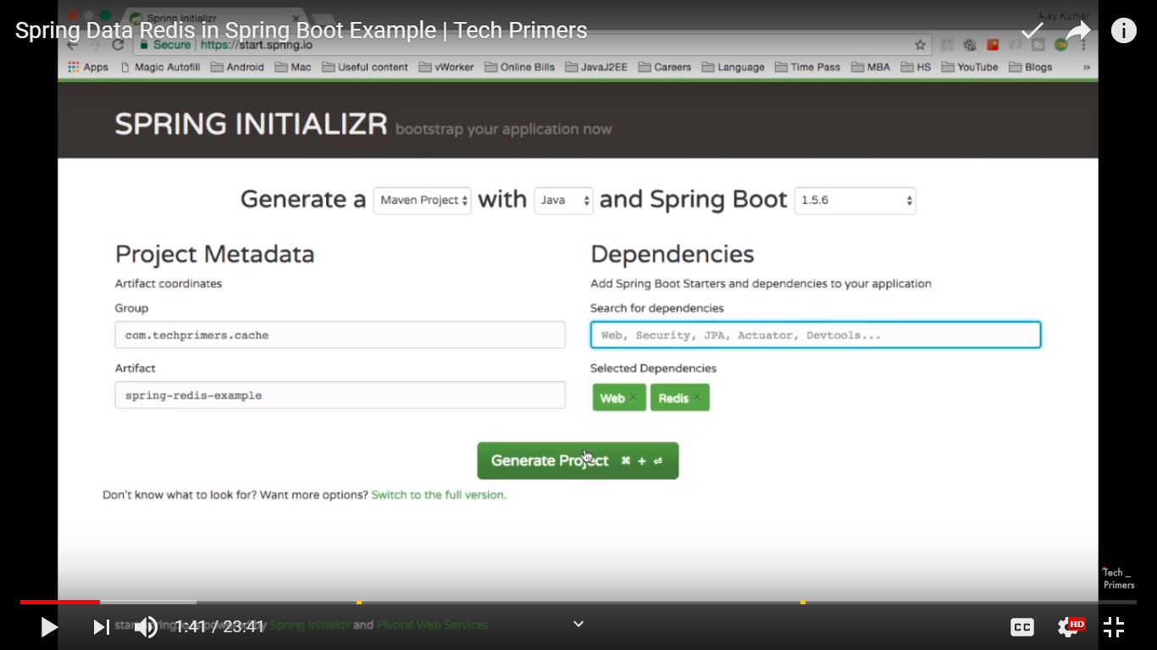

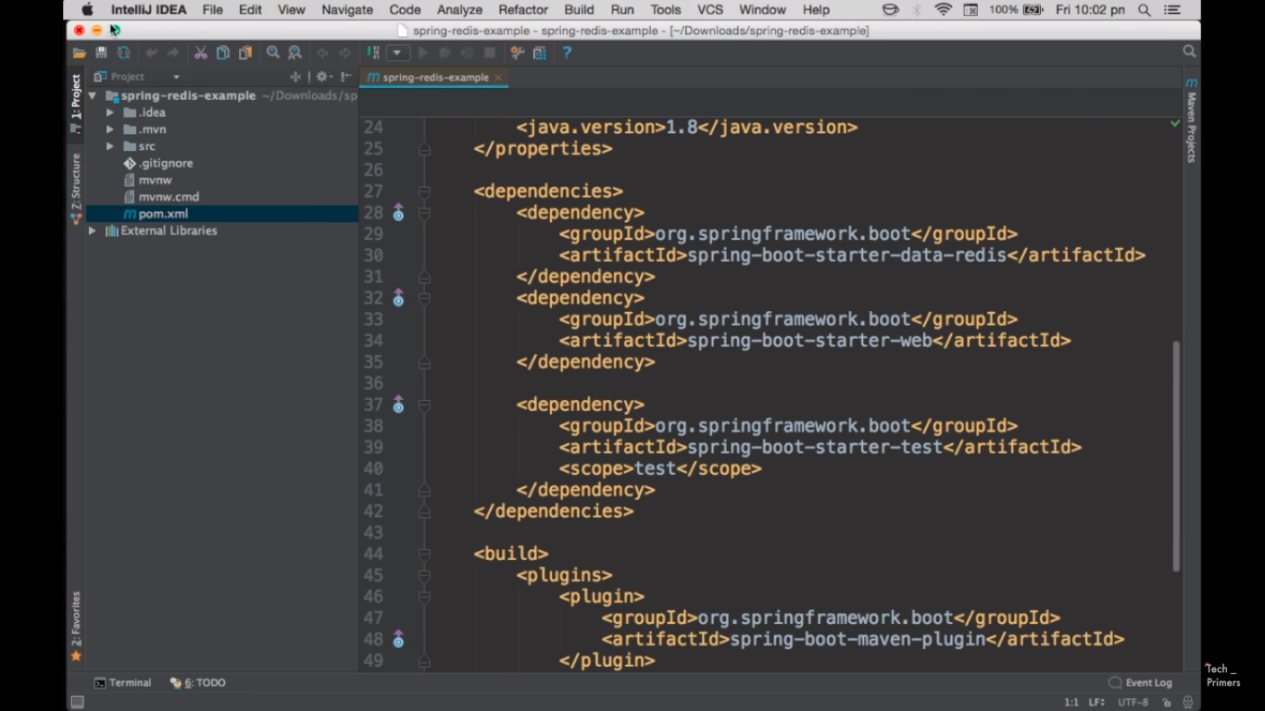

Inside spring-boot-starter-data-redis.

We can add host, port number also.

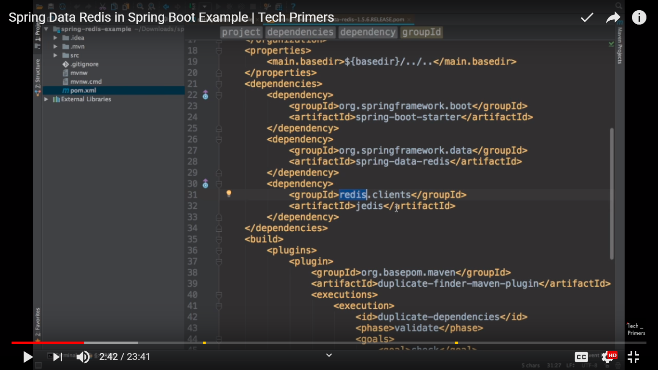

In-built connection factory is JedisConnectionFactory

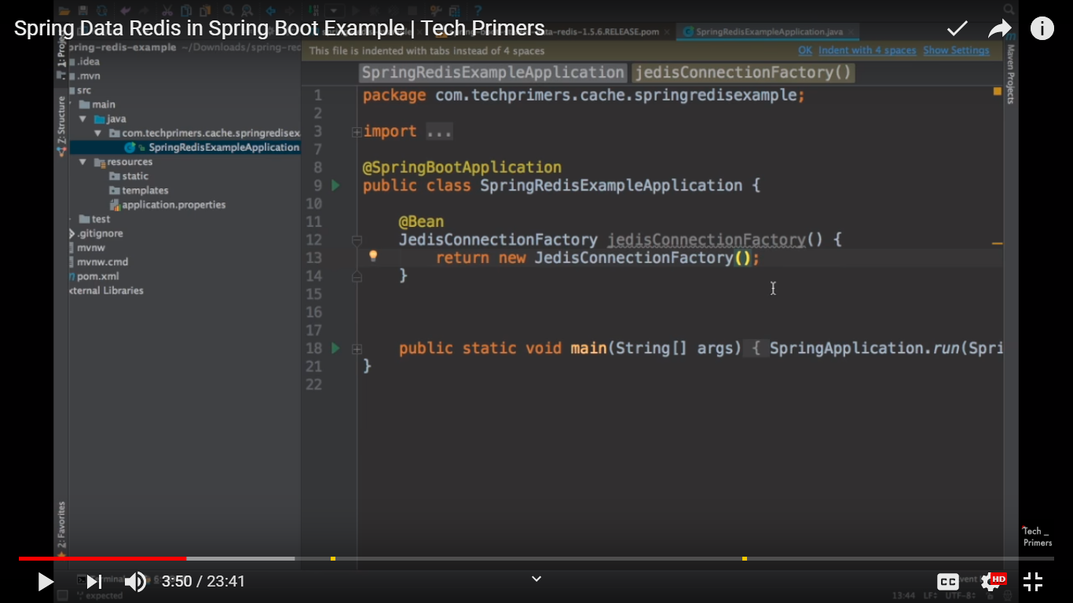

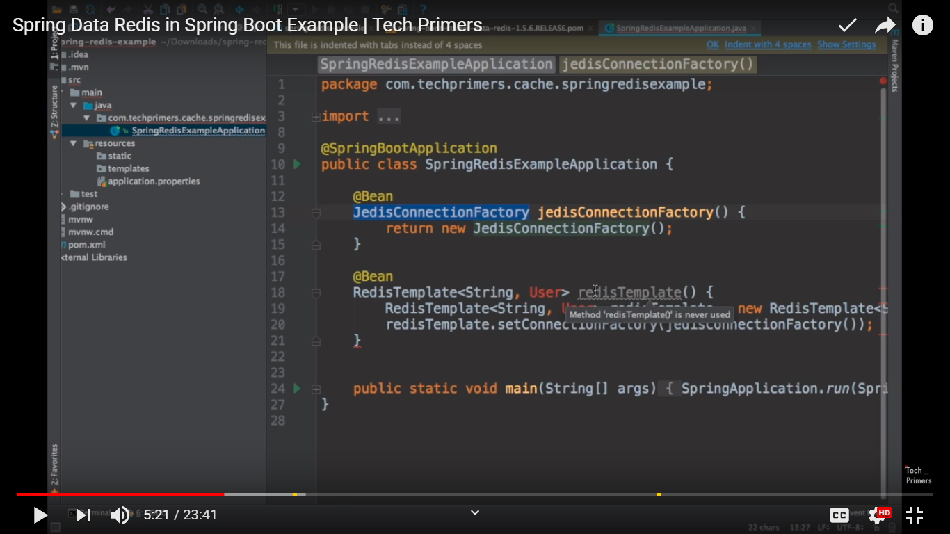

Add parameterized constructor and toString()

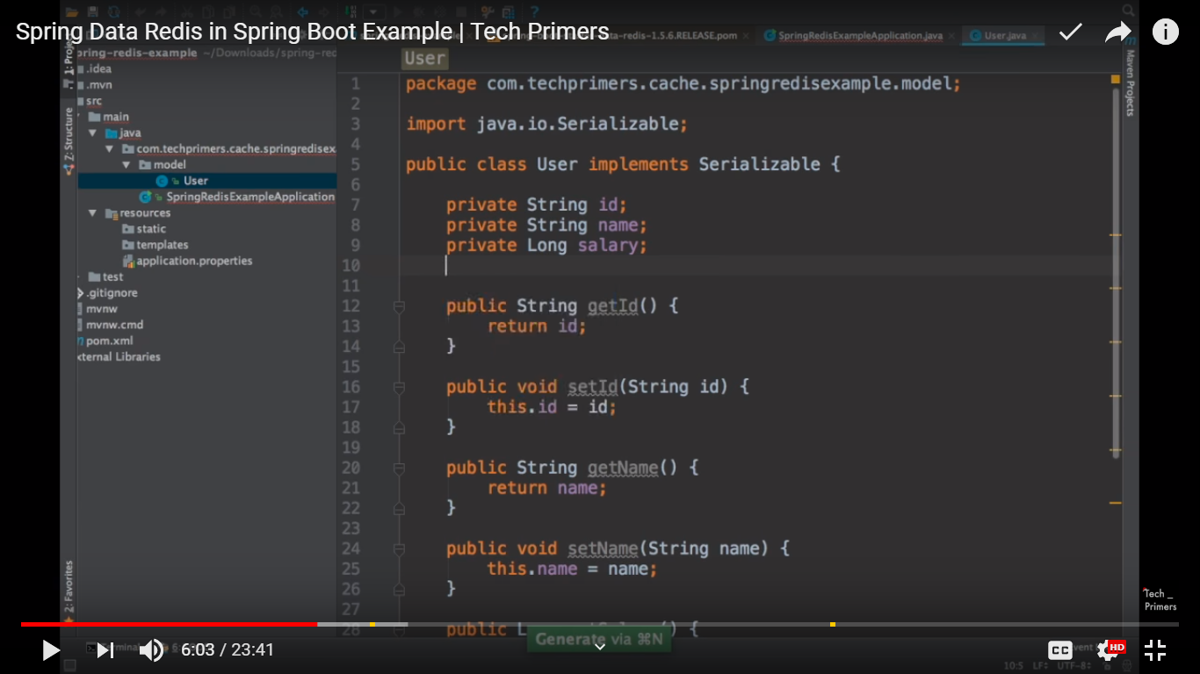

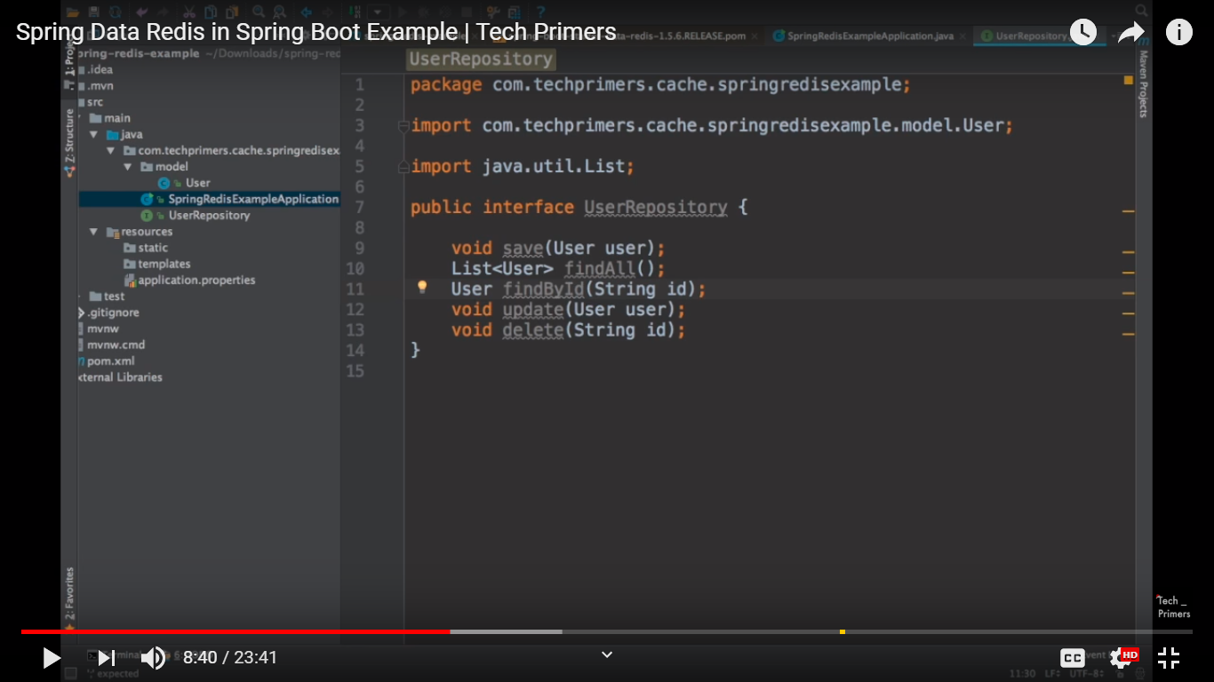

Create an implementation with UserRepository

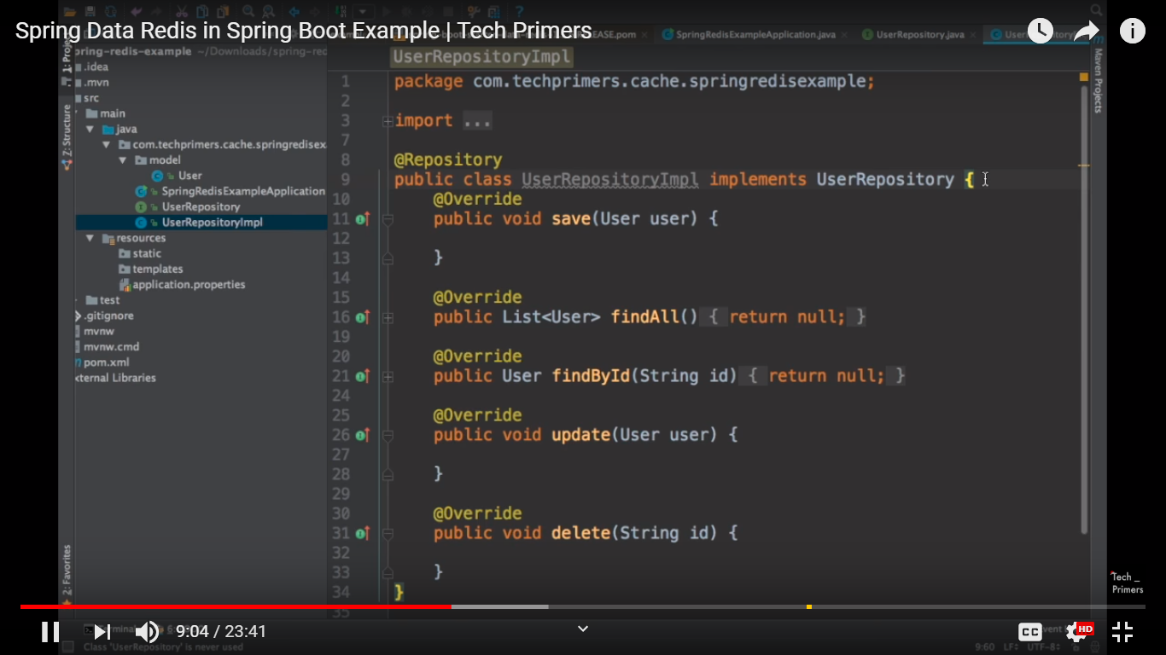

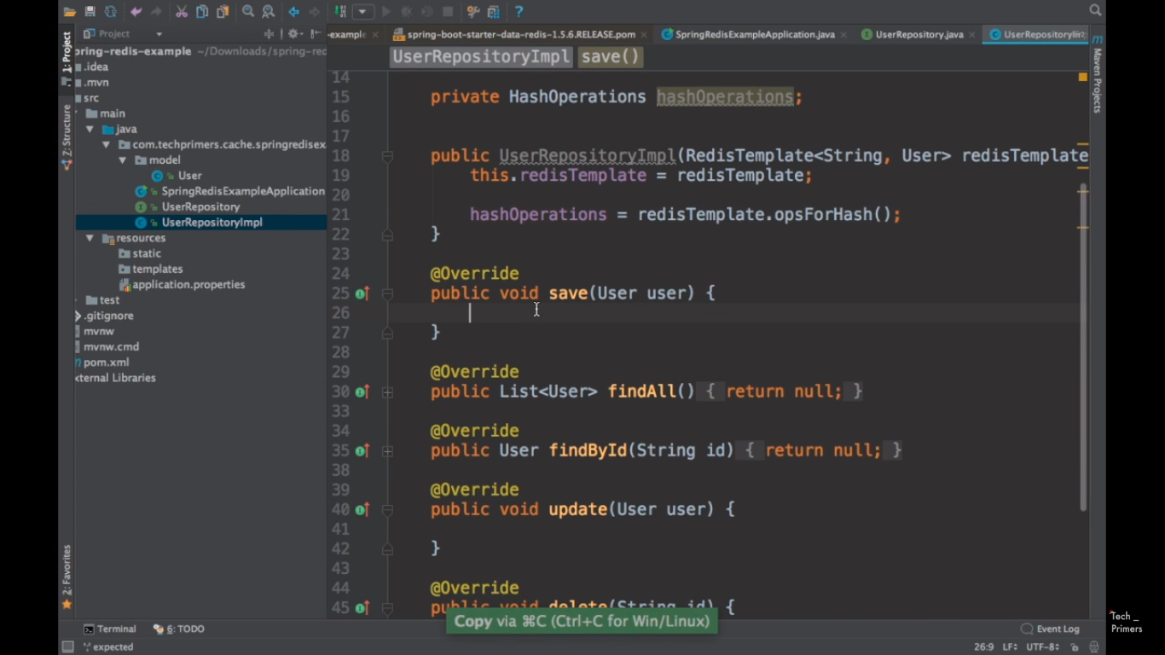

hashOperations.put() is like putting the value into redis cache

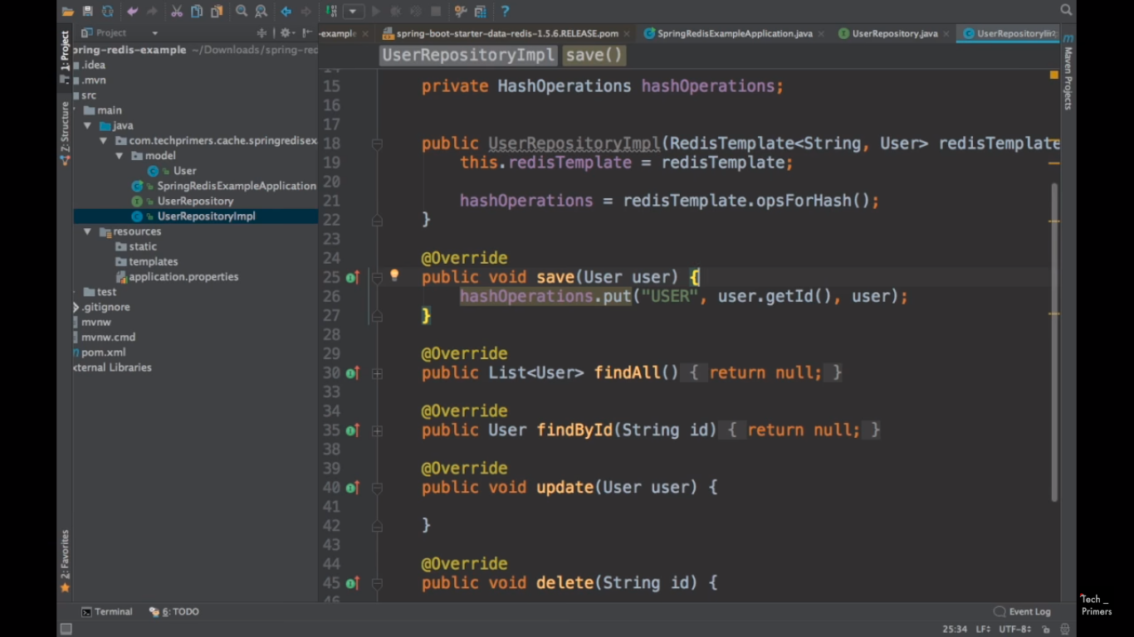

Entries returns Map

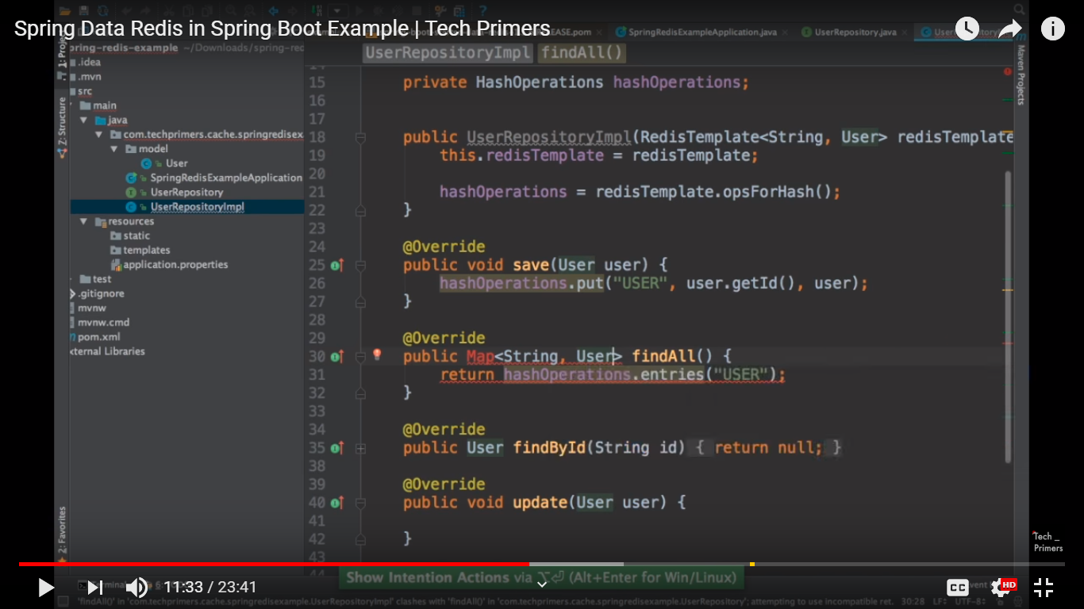

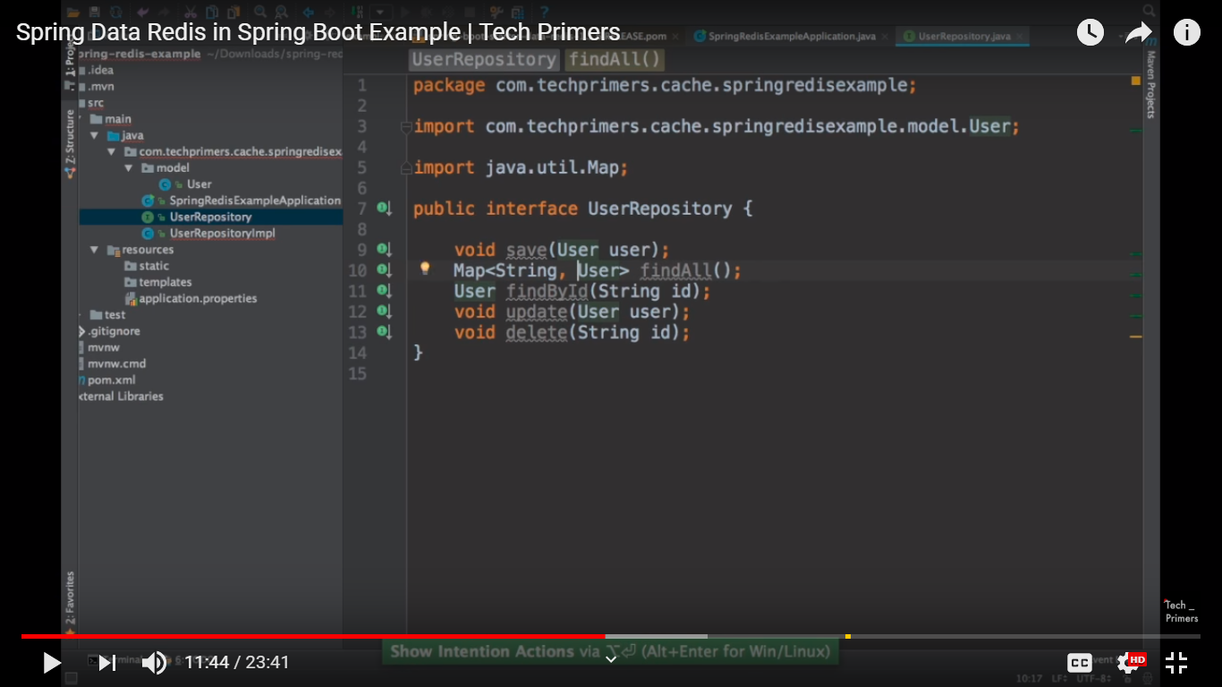

Final implementation

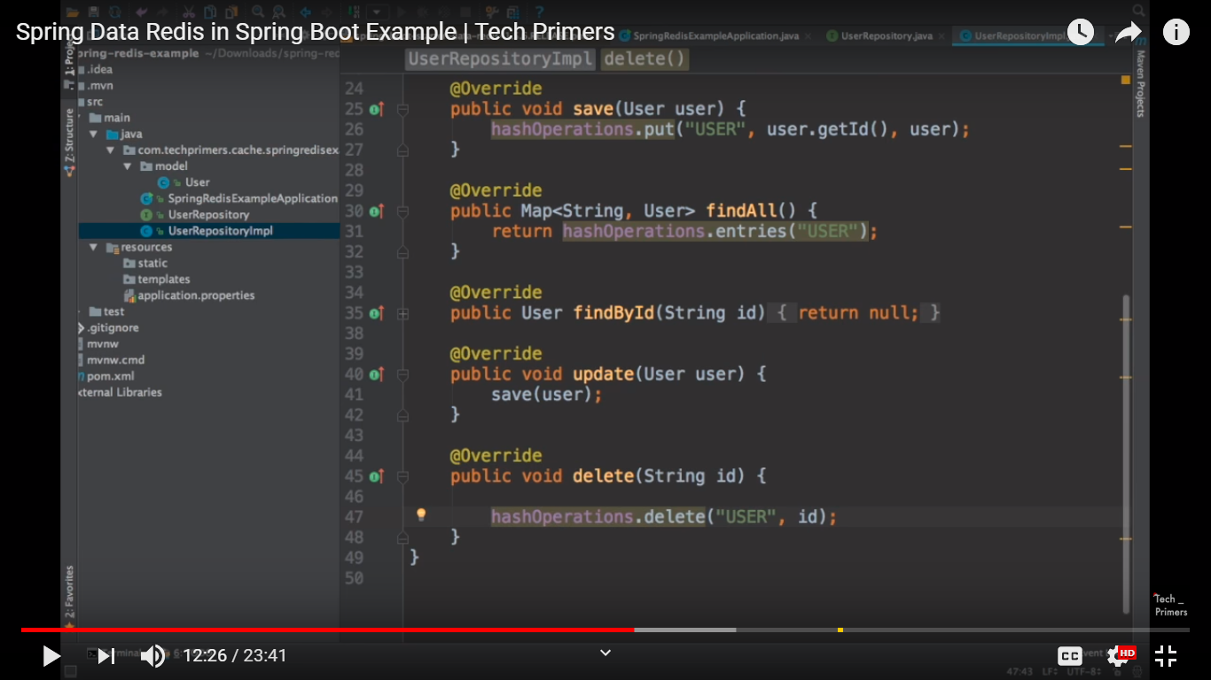

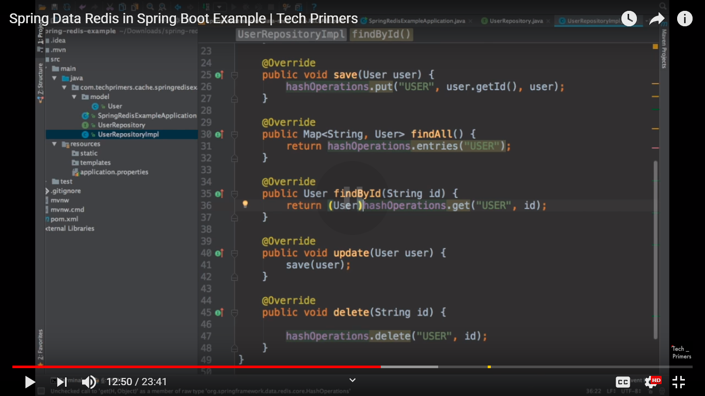

Controller

